Step:1  
In this step the Week02_Export_Health_Details.dtsx package is loaded into Visual studio integration services from test.dbo in Healthcare data(SSMS) and a new project is created using Data Flow Task 1.

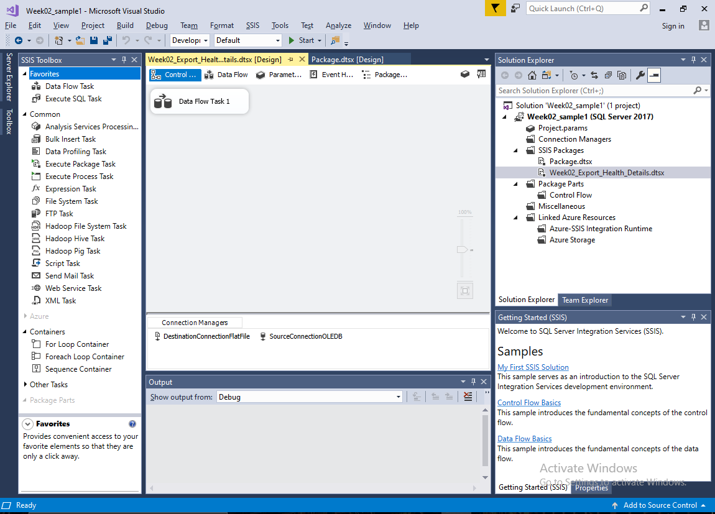



Step2: I have created a source and a destination file transferring whole 1,575,112 rows at the destination location inside Data Flow Task 1.

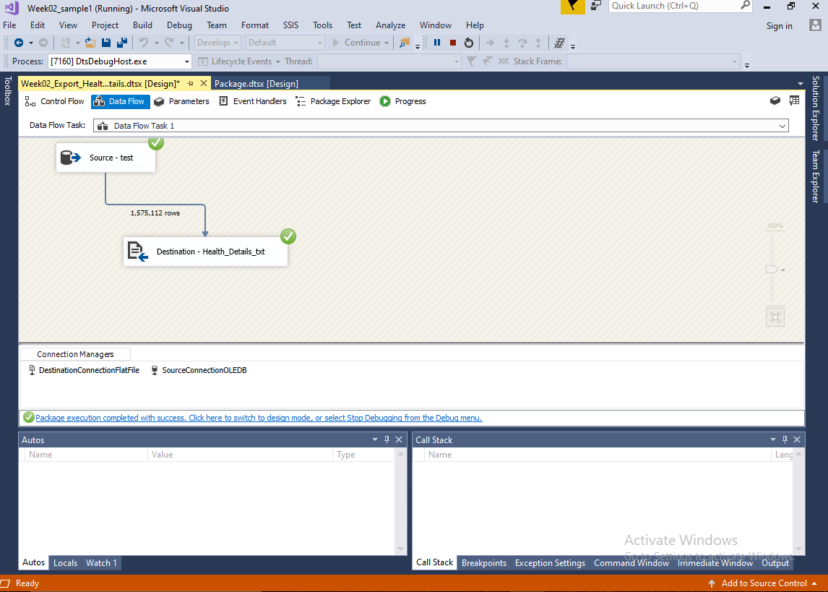



Step3:  
Names of the source and destination files are changed to avoid confusion and make things neat and clear.

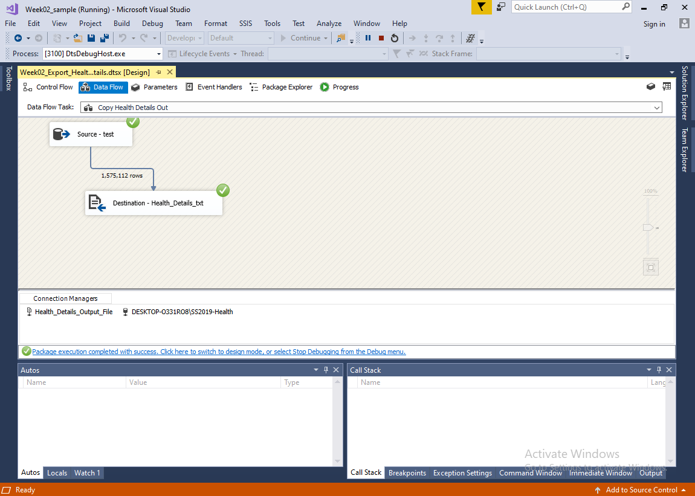



Step4:

All the mappings are corrected and put straight in a same variable.

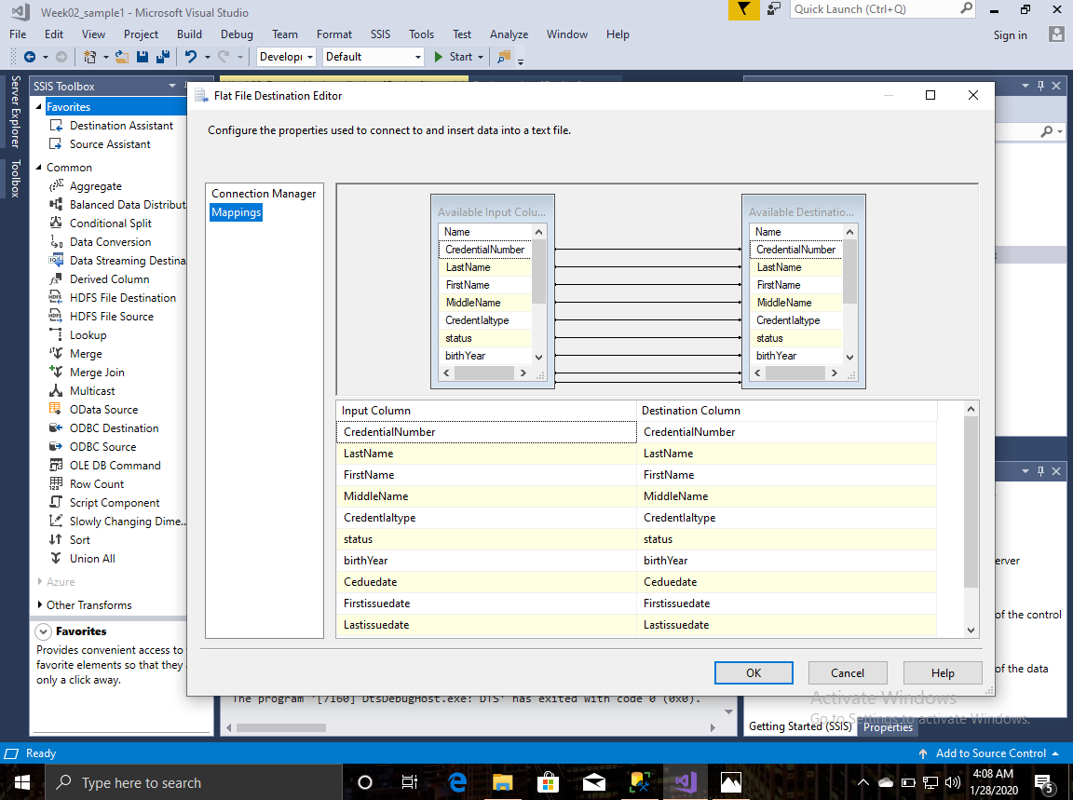

Step5: Proper annotations are made including Name, Version, Date and Export Name.  
